Learning to Allocate Limited Memory in Sequence Models
Ryan Ellis | Advanced Applied Machine Learning | Research proposal
Paper outline: Introduction and Goals; Hypotheses and Method; Related Work; Application and Results; Conclusions.

Problem and candidate solution
Recurrent sequence models use bounded memory but can overwrite information needed later. HOLA adds an exact cache [1], Raven learns sparse memory routing [2], and Proteus progressively activates capacity [3]. I will investigate whether explicitly estimating interference between stored associations improves allocation at a fixed memory budget. My candidate solution is a learned write controller that considers input novelty and conflicts among similar stored keys. Its advantage over existing allocation mechanisms is an untested hypothesis.

Research hypotheses
H1: At matched total memory and training compute, the controller will improve exact recall by at least five percentage points over the strongest validation-selected baseline on tests with 64-128 distinct associations and a 32-slot budget.
H2: Removing the interference signal while holding controller size fixed will reduce this gain, indicating that the signal supplies useful information.

Applied method and dataset
I will train a 20-million-parameter recurrent model in PyTorch with 32, 64, or 128 memory slots. A small neural controller will produce differentiable write gates from the current input and memory, using key similarity and value disagreement as interference features. A simplified slot update is:
$m_{t,j} = (1 − g_{t,j})m_{t−1,j} + g_{t,j}u_{t}$
Here m is a slot vector, u is the incoming representation, and g is a learned gate between zero and one. The model and controller will learn jointly through query-answer cross-entropy.
Data will use Zoology's public multi-query associative recall generator [4], extended with key updates and distractors. I will generate 100,000 training, 5,000 validation, and 10,000 test sequences with disjoint examples and new key-value assignments. I will vary distinct associations, redundancy, and query delay independently; train at 128-512 tokens and test up to 2,048 tokens.
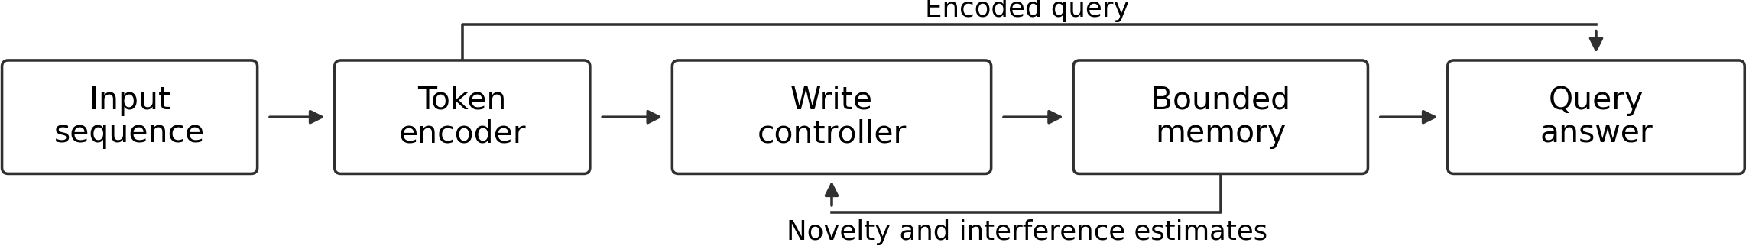

Evaluation and expected learning
Controls will use the same backbone with recency retention, residual-based caching [1], input-only routing [2], or position-based activation [3]. I will match parameter counts and training compute, count all recurrent state, caches, and controller statistics, and tune learning rates and gate settings only on validation data. Across three seeds, I will report exact recall, errors by association density, state bytes, latency, and paired bootstrap 95% confidence intervals. An initial small run will establish GPU memory and runtime. The conclusions will identify when allocation helps, whether the hypotheses hold, and where limited capacity still causes failure; synthetic-task findings will not establish general language-model gains.

References
[1] Cui (2026). A Hippocampus for Linear Attention: An Exact Memory for What the Recurrent State Forgets. arXiv:2607.02303.
[2] Afzal et al. (2026). Raven: High-Recall Sequence Modeling with Sparse Memory Routing. arXiv:2607.25357.
[3] Bayat et al. (2026). Proteus: Incremental Memory Activation for Long-Context Sequence Modeling. arXiv:2608.16844.
[4] Arora et al. (2023). Zoology: Measuring and Improving Recall in Efficient Language Models. arXiv:2312.04927.

